4
Protein Binding of Drugs
A drug in the body can interact with several tissue components of which the two major categories are –
- Blood, and
- Extravascular tissues.
The interacting molecules are generally the macromolecules such as proteins, DNA or adipose. The proteins are particularly responsible for such an interaction. The phenomenon of complex formation with proteins is called as protein binding of drugs.
Protein binding may be divided into –
- Intracellular binding – where the drug is bound to a cell protein which may be the drug receptor; if so, binding elicits a pharmacological response. These receptors with which drug interact to show response are called as primary receptors.
- Extracellular binding – where the drug binds to an extracellular protein but the binding does not usually elicit a pharmacological response. These receptors are called secondary or silent receptors.
The most important extracellular proteins or silent receptors are plasma proteins, in particular albumin. Binding to such proteins is important from the viewpoint that the bound drug is both pharmacokinetically as well as pharmacodynamically inert i.e. an extracellular protein bound drug is neither metabolised nor excreted nor it is active pharmacologically. A bound drug is also restricted since it remains confined to a particular tissue for which it has greater affinity. Moreover, such a bound drug, because of its enormous size, cannot undergo membrane transport and thus its half-life is increased.

Mechanisms of Protein-Drug Binding
Binding of drugs to proteins is generally reversible which suggests that it generally involves weak chemical bonds such as –
- Hydrogen bonds
- Hydrophobic bonds
- Ionic bonds, or
- van der Waal’s forces.
Irreversible drug binding, though rare, arises as a result of covalent binding and is often a reason for the carcinogenicity or tissue toxicity of the drug; for example, covalent binding of chloroform and paracetamol metabolites to liver results in hepatotoxicity.

Binding of drugs falls into 2 classes:
1. Binding of drugs to blood components like—
- Plasma proteins
- Blood cells
2. Binding of drugs to extravascular tissue proteins, fats, bones, etc.

The influence of binding on drug disposition and clinical response is shown in Fig. 4.1.
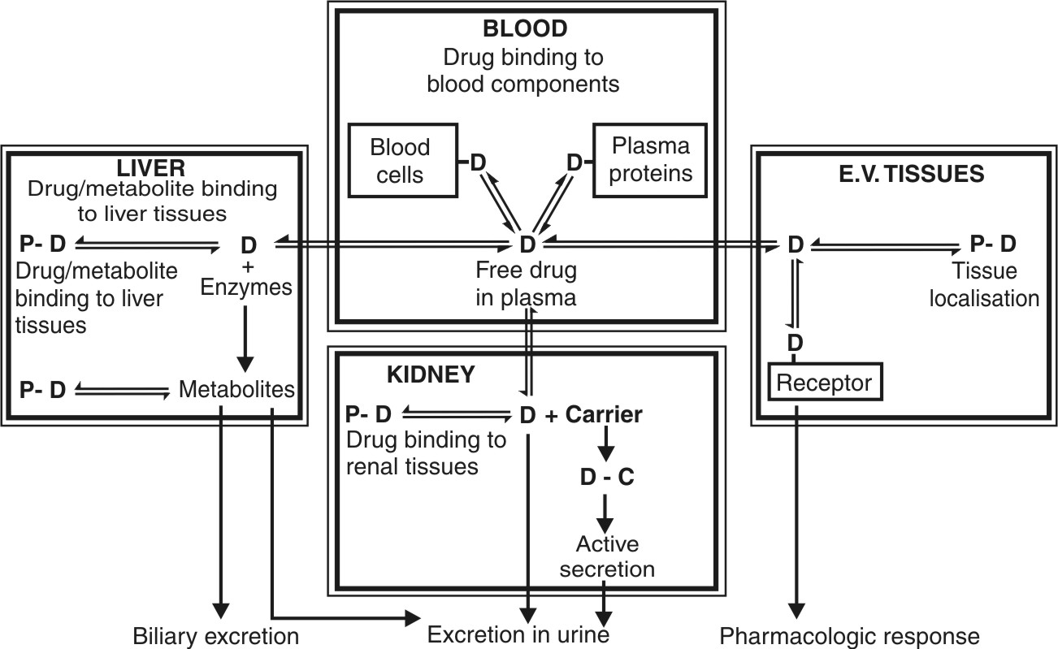
Fig. 4.1. Protein-drug binding: Binding of drugs to various tissue components and its influence on disposition and clinical response. Note that only the unbound drug moves reversibly between the compartments.

Of all types of binding, the plasma protein-drug binding is the most significant and most widely studied.

BINDING OF DRUGS TO BLOOD COMPONENTS
Plasma Protein-Drug Binding
Following entry of a drug into the systemic circulation, the first things with which it can interact are blood components like plasma proteins, blood cells and haemoglobin (see Table 4.1). The main interaction of drug in the blood compartment is with the plasma proteins which are present in abundant amounts and in large variety. The binding of drugs to plasma proteins is reversible. The extent or order of binding of drugs to various plasma proteins is:
Abumin > α1-Acid Glycoprotein > Lipoproteins > Globulins.

Table 4.1
Blood Proteins to which Drugs Bind
Protein | Molecular Weight | Concentration (g%) | Drugs that bind
Human Serum Albumin | 65,000 | 3.5-5.0 | Large variety of all types of drugs
α1-Acid Glycoprotein | 44,000 | 0.04-0.1 | Basic drugs such as imipramine, lidocaine, quinidine, etc.
Lipoproteins | 200,000 to 3,400,000 | Variable | Basic, lipophilic drugs like chlorpromazine
α1-Globulin | 59,000 | 0.003-0.007 | Steroids like corticosterone, and thyroxine and cyanocobalamin
α2-Globulin | 1,34,000 | 0.015-0.06 | Vitamins A, D, E and K and cupric ions
Haemoglobin | 64,500 | 11-16 | Phenytoin, pentobarbital, and phenothiazines

Binding of Drugs to Human Serum Albumin
The human serum albumin (HSA), having a molecular weight of 65,000, is the most abundant plasma protein (59% of total plasma and 3.5 to 5.0 g%) with a large drug binding capacity. The therapeutic doses of most drugs are relatively much smaller and their plasma concentration do not normally reach equimolar concentration with HSA. The HSA can bind several compounds having varied structures. Both endogenous compounds such as fatty acids, bilirubin and tryptophan as well as drugs bind to HSA. A large variety of drugs ranging from weak acids, neutral compounds to weak bases bind to HSA. Four different sites on HSA have been identified for drug-binding (Fig. 4.2). They are:

Site I: Also called as warfarin and azapropazone binding site, it represents the region to which large number of drugs are bound, e.g. several NSAIDs (phenylbutazone, naproxen, indomethacin), sulphonamides (sulphadimethoxine, sulphamethizole), phenytoin, sodium valproate and bilirubin.
Site II: It is also called as the diazepam binding site. Drugs which bind to this region include benzodiazepines, medium chain fatty acids, ibuprofen, ketoprofen, tryptophan, cloxacillin, probenicid, etc.
Site I and site II are responsible for the binding of most drugs.
Site III: is also called as digitoxin binding site.
Site IV: is also called as tamoxifen binding site.

Very few drugs bind to sites III and IV.
A drug can bind to more than one site in which case the main binding site is called as the primary site and the other as the secondary site; for example, site I is the primary site for dicoumarol and site II the secondary site. Groups of drugs that bind to the same site compete with each other for binding, but drugs that bind to one site do not competitively inhibit binding of drugs to other sites. However, they may either promote or retard binding of a drug to another site by energetic coupling mechanisms.
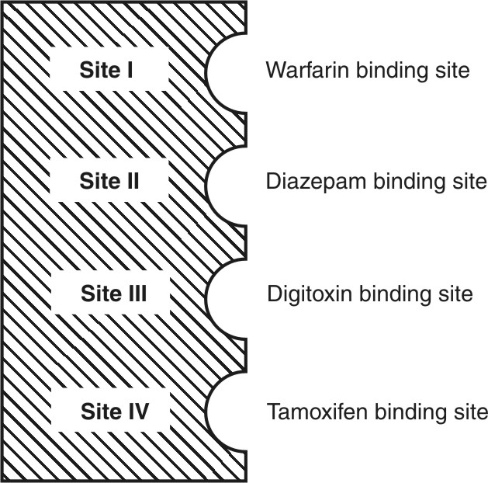
Fig. 4.2. Four major drug-binding sites on human serum albumin

Binding of Drugs to α1-Acid Glycoprotein (α1-AGP or AAG)
Also called as the orosomucoid, it has a molecular weight of 44,000 and a plasma concentration range of 0.04 to 0.1 g%. It binds to a number of basic drugs like imipramine, amitriptyline, nortriptyline, lidocaine, propranolol, quinidine and disopyramide.

Binding of Drugs to Lipoproteins
Binding of drugs to HSA and AAG involve hydrophobic bonds. Since only lipophilic drugs can undergo hydrophobic bonding, lipoproteins can also bind to such drugs because of their high lipid content. However, the plasma concentration of lipoproteins is much less in comparison to HSA and AAG.
A drug that binds to lipoproteins does so by dissolving in the lipid core of the protein and thus its capacity to bind depends upon its lipid content. The molecular weight of lipoproteins varies from 2 lakhs to 34 lakhs depending on their chemical composition. They are classified on the basis of their density into 4 categories –
- Chylomicrons (least dense and largest in size).
- Very low density lipoproteins (VLDL).
- Low-density lipoproteins (LDL) (predominant in humans).
- High-density lipoproteins (HDL) (most dense and smallest in size).

The hydrophobic lipid core of these macromolecules consists of triglycerides and cholesteryl esters and the relatively hydrophilic surface is made of apoproteins (free cholesterol and proteins). Predictably, VLDL is rich in triglycerides and HDL is rich in apoproteins.
Binding of drugs to lipoproteins is non-competitive i.e. there are no specific or non-specific binding sites and binding is not dependent on drug concentration. Binding rather reflects partitioning of drugs in hydrophobic core of lipoprotein molecule. A number of acidic (diclofenac), neutral (cyclosporin A) and basic drugs (chlorpromazine) bind to lipoproteins. Basic, lipophilic drugs have relatively more affinity. Lipoprotein binding becomes significant in cases of drugs that predominantly bind to them, and secondly, when levels of HSA and AAG in plasma are decreased.
The main physiological role of lipoproteins is circulation of lipids to tissues through the blood. Similarly, lipoproteins also play an important role in the transport of drugs to tissues.

Binding of Drugs to Globulins
Several plasma globulins have been identified and are labelled as α1-, α2-, β1-, β2- and γ-globulins.
- α1-globulin: also called as transcortin or CBG (corticosteroid binding globulin), it binds a number of steroidal drugs such as cortisone and prednisone. It also binds to thyroxine and cyanocobalamin.
- α2-globulin: also called as ceruloplasmin, it binds vitamins A, D, E and K and cupric ions.
- β1-globulin: also called as transferrin, it binds to ferrous ions.
- β2-globulin: binds to carotinoids.
- γ-globulin: binds specifically to antigens.

Binding of Drugs to Blood Cells
More than 40% of the blood comprises of blood cells of which the major cell component is the RBC. The RBCs constitute 95% of the total blood cells. Thus, significant RBC drug binding is possible. The red cell is 500 times in diameter as the major plasma protein binding component, albumin. The RBC comprises of 3 components each of which can bind to drugs:

- Haemoglobin: It has a molecular weight of 64,500 (almost equal to that of HSA) but is 7 to 8 times the concentration of albumin in blood. Drugs like phenytoin, pentobarbital and phenothiazines bind to haemoglobin.
- Carbonic Anhydrase: Drugs known to bind to it are acetazolamide and chlorthalidone (i.e. carbonic anhydrase inhibitors).
- Cell Membrane: Imipramine and chlorpromazine are reported to bind with the RBC membrane.
It has been shown that the rate and extent of entry into RBC is more for lipophilic drugs, e.g. phenytoin. Hydrophilic drugs like ampicillin do not enter RBC.

TISSUE BINDING OF DRUGS
(Tissue Localization of Drugs)
The body tissues, apart from HSA, comprise 40% of the body weight which is 100 times that of HSA. Hence, tissue-drug binding is much more significant than thought to be.

A drug can bind to one or more of the several tissue components. Tissue-drug binding is important in distribution from two viewpoints:
- It increases the apparent volume of distribution of drugs in contrast to plasma protein binding which decreases it. This is because the parameter is related to the ratio of amount of drug in the body to the plasma concentration of free drug and the latter is decreased under conditions of extensive tissue binding of drugs.
- Tissue-drug binding results in localization of a drug at a specific site in the body (with a subsequent increase in biological half-life). This is more so because a number of drugs bind irreversibly with the tissues (contrast to plasma protein-drug binding); for example, oxidation products of paracetamol, phenacetin, chloroform, carbon tetrachloride and bromobenzene bind covalently to hepatic tissues.

Factors influencing localization of drugs in tissues include lipophilicity and structural features of the drug, perfusion rate, pH differences, etc. Extensive tissue-drug binding suggests that a tissue can act as the storage site for drugs. Drugs that bind to both tissue and plasma components result in competition between drug binding sites.
For majority of drugs that bind to extravascular tissues, the order of binding is:
Liver > Kidney > Lung > Muscles

Several examples of extravascular tissue-drug binding are:
- Liver: As stated earlier, epoxides of a number of halogenated hydrocarbons and paracetamol bind irreversibly to liver tissues resulting in hepatotoxicity.
- Lungs: Basic drugs like imipramine, chlorpromazine and antihistamines accumulate in lungs.
- Kidneys: Metallothionin, a protein present in kidneys, binds to heavy metals such as lead, mercury, and cadmium and results in their renal accumulation and toxicity.
- Skin: Chloroquine and phenothiazines accumulate in skin by interacting with melanin.
- Eyes: The retinal pigments of the eye also contain melanin. Binding of chloroquine and phenothiazines to it is responsible for retinopathy.
- Hairs: Arsenicals, chloroquine and phenothiazines are reported to deposit in hair shafts.
- Bones: Tetracycline is a well-known example of a drug that binds to bones and teeth. Administration of this antibiotic to infants or children during odontogenesis results in permanent brown-yellow discoloration of teeth. Lead is known to replace calcium from bones and cause their brittleness.
- Fats: Lipophilic drugs such as thiopental and the pesticide DDT accumulate in adipose tissues by partitioning into it. However, high o/w partition coefficient is not the only criteria for adipose distribution of drugs since several highly lipophilic (more than thiopental) basic drugs like imipramine and chlorpromazine are not localized in fats. The poor perfusion of adipose could be the reason for such an ambiguity. Reports have stated that adipose localization of drugs is a result of binding competition between adipose and non-adipose tissues (lean tissues like muscles, skin and viscera) and not partitioning.
- Nucleic Acids: Molecular components of cells such as DNA interact strongly with drugs like chloroquine and quinacrine resulting in distortion of its double helical structure.

Table 4.2 compares plasma protein-drug binding and tissue-drug binding.

Table 4.2
Comparison Between Plasma Protein-Drug Binding and Tissue-Drug Binding
 | Plasma protein-drug binding | Tissue-drug binding
1. | Binding involves weak bonds and thus reversible. | Binding generally involves strong covalent bonds and thus irreversible.
2. | Drugs that bind to plasma proteins have small apparent volume of distribution. | Drugs that bind to extravascular tissues have large apparent volume of distribution.
3. | Half-life of plasma protein bound drug is relatively short. | Half-life of extravascular tissue bound drug is relatively long.
4. | Does not result in toxicity. | Tissue toxicity is common.
5. | Displacement from binding sites is possible by other drugs. | Displacement by other drugs generally does not occur.
6. | Competition between drugs for binding to plasma proteins can occur. | Tissue-drug binding is generally non-competitive.

Determination of protein-drug binding
The analytical techniques used in protein binding studies can be divided into two classes –
- Indirect techniques are those based on the separation of bound form from the free micromolecule. These techniques are usually applied in biological samples (blood, serum, plasma) for the determination of the percentage of binding. Indirect analytical methods used in protein binding studies are equilibrium dialysis, dynamic dialysis, ultrafiltration, diafiltration, ultracentrifugation, gel filtration, etc.
- Direct techniques are those that do not require the separation of bound form of drug from the free micromolecule. These methods are used for the estimation of the number and the elucidation of the character of binding sites in pure aqueous solutions of proteins. Direct techniques used in protein binding studies are UV spectroscopy, fluorimetry, and ion-selective electrodes.

FACTORS AFFECTING PROTEIN-DRUG BINDING
Factors affecting protein-drug binding can be broadly categorized as—
1. Drug related factors
- Physicochemical characteristics of the drug
- Concentration of drug in the body
- Affinity of a drug for a particular binding component
2. Protein/tissue related factors
- Physicochemical characteristics of the protein or binding agent
- Concentration of protein or binding component
- Number of binding sites on the binding agent
3. Drug interactions
a. Competition between drugs for the binding site (displacement interactions)
b. Competition between the drug and normal body constituents
c. Allosteric changes in protein molecule
4. Patient related factors
- Age
- Intersubject variations
- Disease states

DRUG RELATED FACTORS
Physicochemical Characteristics of the Drug
As mentioned earlier, protein binding is directly related to the lipophilicity of drug. An increase in lipophilicity increases the extent of binding, for example, the slow absorption of cloxacillin in comparison to ampicillin after i.m. injection is attributed to its higher lipophilicity and larger (95%) binding to proteins while the latter is less lipophilic and just 20% bound to proteins. Highly lipophilic drugs such as thiopental tend to localize in adipose tissues. Anionic or acidic drugs such as penicillins and sulphonamides bind more to HSA whereas cationic or basic drugs such as imipramine and alprenolol bind to AAG. Neutral, unionised drugs bind more to lipoproteins.
Stereoselectivity in protein binding of enantiomeric drugs has also been demonstrated. Acidic drugs such as etodolac, flurbiprofen, ibuprofen, moxalactam, pentobarbital, phenprocoumon, and warfarin and for basic drugs such as chloroquine, disopyramide, methadone, propranolol, mexiletine, and verapamil show stereoselective binding.

Concentration of Drug in the Body
The extent of protein-drug binding can change with both changes in drug as well as protein concentration. The concentration of drugs that bind to HSA does not have much of an influence, as the therapeutic concentration of any drug is insufficient to saturate it. However, therapeutic concentration of lidocaine can saturate AAG with which it binds as the concentration of AAG is much less in comparison to that of HSA in blood.

Drug-Protein/Tissue Affinity
Lidocaine has greater affinity for AAG than for HSA. Digoxin has more affinity for proteins of cardiac muscles than those of skeletal muscles or plasma. Iophenoxic acid, a radio-opaque medium, has so great an affinity for plasma proteins that it has a half-life of 2½ years.

PROTEIN/TISSUE RELATED FACTORS
Physicochemical Properties of Protein/Binding Component
Lipoproteins and adipose tissue tend to bind lipophilic drugs by dissolving them in their lipid core. The physiologic pH determines the presence of active anionic and cationic groups on the albumin molecules to bind a variety of drugs.

Concentration of Protein/Binding Component
Among the plasma proteins, binding predominantly occurs with albumin, as it is present in a higher concentration in comparison to other plasma proteins. The amount of several proteins and tissue components available for binding, changes during disease states. This effect will be discussed in the subsequent sections.

Number of Binding Sites on the Protein
Albumin has a large number of binding sites as compared to other proteins and is a high capacity binding component. Several drugs are capable of binding at more than one site on albumin, e.g. fluocloxacillin, flurbiprofen, ketoprofen, tamoxifen and dicoumarol bind to both primary and secondary sites on albumin. Indomethacin is known to bind to 3 different sites. AAG is a protein with limited binding capacity because of its low concentration and low molecular size. Though pure AAG has only one binding site for lidocaine, in presence of HSA, two binding sites have been reported which was suggested to be due to direct interaction between HSA and AAG.

DRUG INTERACTIONS
Competition Between Drugs for the Binding Sites (Displacement Interactions)
When two or more drugs can bind to the same site, competition between them for interaction with the binding site results. If one of the drugs (drug A) is bound to such a site, then administration of another drug (drug B) having affinity for the same site results in displacement of drug A from its binding site. Such a drug-drug interaction for the common binding site is called as displacement interaction. The drug A here is called as the displaced drug and drug B as the displacer. Warfarin and phenylbutazone have same degree of affinity for HSA. Administration of phenylbutazone to a patient on warfarin therapy results in displacement of latter from its binding site. The free warfarin may cause adverse hemorrhagic reactions which may be lethal. Phenylbutazone is also known to displace sulphonamides from their HSA binding sites. Displacement interactions can result in unexpected rise in free concentration of the displaced drug which may enhance clinical response or toxicity. Even a drug metabolite can affect displacement interaction.

Clinically significant interactions will result when:
I. The displaced drug (e.g. warfarin) —
- Is more than 95% bound.
- Has a small volume of distribution (less than 0.15 L/Kg).
- Shows a rapid onset of therapeutic or adverse effects.
- Has a narrow therapeutic index.
II. The displacer drug (e.g. phenylbutazone) —
- Has a high degree of affinity as the drug to be displaced.
- Competes for the same binding sites.
- The drug/protein concentration ratio is high (above 0.10).
- Shows a rapid and large increase in plasma drug concentration.

It will be worthwhile to mention here that, both the concentration of the displacer drug and its affinity for the binding site with respect to that of the drug to be displaced, will determine the extent to which displacement will occur.
For a drug that is 95% bound, a displacement of just 5% of the bound drug results in a 100% rise in free drug concentration. If the displaced drug has a small volume of distribution, it remains confined to the blood compartment and shows serious toxic responses. On the contrary, if such a drug has a large Vd, it redistributes into a large volume of body fluids and clinical effects may be negligible or insignificant. The increase in free drug concentration following displacement also makes it more available for elimination by the liver and the kidneys (Fig. 4.3). If the drug is easily metabolisable or excretable, its displacement results in significant reduction in elimination half-life.
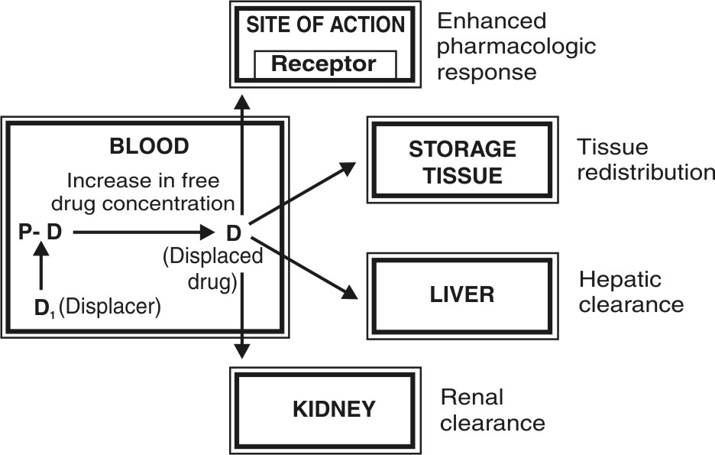
Fig. 4.3. Fate of a drug after displacement interaction
Displacement also becomes insignificant with the use of more selective, potent, low dose drugs.
Besides the direct displacement interaction discussed above, indirect interactions are also possible. For example, the use of heparin as an anticoagulant activates lipoprotein lipase, an enzyme which metabolises triglycerides to free fatty acids. Heparin co-administration with drugs has also been shown to result in decreased protein binding of propranolol, quinidine, etc. via its effects on fatty acid levels.

Competition Between Drugs and Normal Body Constituents
Among the various normal body constituents, the free fatty acids are known to interact with a number of drugs that bind primarily to HSA. The free fatty acid level is increased in several physiologic (fasting), pathologic (diabetes, myocardial infarction, alcohol abstinence) and pharmacologically induced conditions (after heparin and caffeine administration). The fatty acids, which also bind to albumin, influence binding of several benzodiazepines and propranolol (decreased binding) and warfarin (increased binding). Bilirubin binding to HSA can be impaired by certain drugs and is of great concern in neonates whose BBB and bilirubin metabolising capacity are not very efficient. Acidic drugs such as sodium salicylate, sodium benzoate and sulphonamides displace bilirubin from its albumin-binding site. The free bilirubin is not conjugated by the liver of the neonates and thus crosses the BBB and precipitates the condition called as kernicterus (characterized by degeneration of brain and mental retardation).

Allosteric Changes in Protein Molecule
This is yet another mechanism by which drugs can affect protein-binding interactions. The process involves alteration of the protein structure by the drug or its metabolite thereby modifying its binding capacity. The agent that produces such an effect is called as allosteric effector, e.g. aspirin acetylates the lysine fraction of albumin thereby modifying its capacity to bind NSAIDs like phenylbutazone (increased affinity) and flufenamic acid (decreased affinity).

PATIENT RELATED FACTORS
Age
Modification in protein-drug binding as influenced by age of the patient is mainly due to differences in the protein content in various age groups.
    - Neonates: Albumin content is low in newborn; as a result, the unbound concentration of drug that primarily binds to albumin, for example phenytoin and diazepam, is increased.
    - Young infants: An interesting example of differences in protein-drug binding in infants is that of digoxin. Infants suffering from congestive cardiac failure are given a digitalizing dose 4 to 6 times the adult dose on body weight basis. This is contrary to one's belief that infants should be given low doses considering their poorly developed drug eliminating system. The reason attributed for use of a large digoxin dose is greater binding of the drug in infants (the other reason is abnormally large renal clearance of digoxin in infants).
    - Elderly: In old age, the albumin content is lowered and free concentration of drugs that bind primarily to it is increased. Old age is also characterized by an increase in the levels of AAG and thus decreased free concentration is observed for drugs that bind to it. The situation is complex and difficult to generalize for drugs that bind to both HSA and AAG, e.g. lidocaine and propranolol.

Intersubject Variations
Intersubject variability in drug binding as studied with few drugs showed that the difference is small and no more than two fold. These differences have been attributed to genetic and environmental factors.

Disease States
Several pathologic conditions are associated with alteration in protein content. Since albumin is the major drug binding protein, hypoalbuminaemia can severely impair protein-drug binding. Hypoalbuminaemia is caused by several conditions like aging, CCF, trauma, burns, inflammatory states, renal and hepatic disorders, pregnancy, surgery, cancer, etc. Almost every serious chronic illness is characterized by decreased albumin content. Some of the diseases that modify protein-drug binding are depicted in Table 4.3. Hyperlipoproteinaemia, caused by hypothyroidism, obstructive liver disease, alcoholism, etc., affects binding of lipophilic drugs.

Table 4.3.
Influence of Disease States on Protein-Drug Binding
Disease | Influence on Plasma Protein | Influence on Protein-Drug Binding
Renal failure (uremia) | Decreased albumin content | Decreased binding of acidic drugs; neutral and basic drugs unaffected
Hepatic failure | Decreased albumin synthesis | Decreased binding of acidic drugs; binding of basic drugs is normal or reduced depending on AAG levels
Inflammatory states (trauma, surgery, burns, infections, etc.) | Increased AAG levels | Increased binding of basic drugs; neutral and acidic drugs unaffected

Putting in a nutshell, all factors, especially drug interactions and patient related factors that affect protein or tissue binding of drugs, influence:
- Pharmacokinetics of drugs: A decrease in plasma protein—drug binding i.e. an increase in unbound drug concentration, favours tissue redistribution and/or clearance of drugs from the body (enhanced biotransformation and excretion).
- Pharmacodynamics of drugs: An increase in concentration of free or unbound drug results in increased intensity of action (therapeutic/toxic).

SIGNIFICANCE OF PROTEIN/TISSUE BINDING OF DRUGS
Absorption
The absorption equilibrium is attained by transfer of free drug from the site of administration into the systemic circulation and when the concentration in these two compartments become equal. Following equilibrium, the process may stop. However, binding of the absorbed drug to plasma proteins decreases free drug concentration and disturbs such equilibrium. Thus, sink conditions and the concentration gradient are re-established which now act as the driving force for further absorption. This is particularly useful in case of ionised drugs which are transported with difficulty.

Systemic Solubility of Drugs
Water insoluble drugs, neutral endogenous macromolecules such as heparin and several steroids and oil soluble vitamins are circulated and distributed to tissues by binding especially to lipoproteins which act as a vehicle for such hydrophobic compounds.

Distribution
Plasma protein binding restricts the entry of drugs that have specific affinity for certain tissues. This prevents accumulation of a large fraction of drug in such tissues and thus, subsequent toxic reactions. Plasma protein-drug binding thus favours uniform distribution of drugs throughout the body by its buffer function (maintains equilibrium between the free and the bound drug). A protein bound drug in particular does not cross the BBB, the placental barrier and the glomerulus.

Tissue Binding, Apparent Volume of Distribution and Drug Storage
A drug that is extensively bound to blood components remains confined to blood. Such a drug has a small volume of distribution. A drug that shows extravascular tissue binding has a large volume of distribution. A tissue or blood component that has great affinity for a particular drug acts as a depot or storage site for that drug; for example, RBC is a storage site for the lipophilic compound tetrahydrocannabinol.
The relationship between tissue-drug binding and apparent volume of distribution can be established as follows –
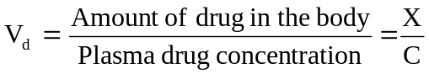 | (4.1)
 | (4.2)
Similarly, we can write,

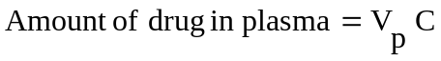 | (4.3)
 | (4.4)
The total amount of drug in the body is the sum of amount of drug in plasma and the amount of drug in extravascular tissues. Thus,
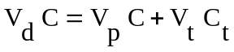 | (4.5)
Where, Vd = apparent volume of distribution of drug
Vp = volume of plasma
Vt = volume of extravascular tissues
Ct = tissue drug concentration
Dividing equation 4.5 with C we get:
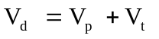 | (4.6)
The fraction of drug unbound (fu) in plasma is given as:
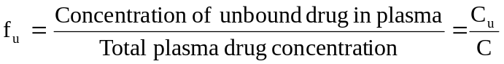 | (4.7)
Similarly, fraction of drug unbound to tissues is:
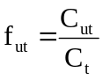 | (4.8)
Assuming that at distribution equilibrium, the unbound or free drug concentration in plasma equals that in extravascular tissues i.e. Cu = Cut, equations 4.7 and 4.8 can be combined to give:
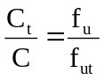 | (4.9)
Substitution of equation 4.9 in 4.6 yields:
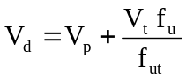 | (4.10)
From equation 4.10 it is clear that greater the unbound or free concentration of drug in plasma, larger its Vd.

Elimination
Only the unbound or free drug is capable of being eliminated. This is because the drug-protein complex cannot penetrate into the metabolising organ (liver). The large molecular size of the complex also prevents it from getting filtered through the glomerulus. Thus, drugs which are more than 95% bound are eliminated slowly i.e. they have long elimination half-lives; for example, tetracycline, which is only 65% bound, has an elimination half-life of 8.5 hours in comparison to 15.1 hours of doxycycline which is 93% bound to plasma proteins. However, penicillins have short elimination half-lives despite being extensively bound to plasma proteins. This is because rapid equilibration occurs between the free and the bound drug and the free drug is equally rapidly excreted by active secretion in renal tubules.

Displacement Interactions and Toxicity
As stated earlier, displacement interactions are significant in case of drugs which are more than 95% bound. This is explained from the example given in Table 4.4. A displacement of just 1% of a 99% bound drug results in doubling of the free drug concentration i.e. a 100% rise. For a drug that is bound to a lesser extent e.g. 90%, displacement of 1% results in only a 10% rise in free drug concentration which may be insignificant clinically.

Table 4.4.
Influence of Percent Binding and Displacement on Change in Free Concentration of Drugs
Drug A Drug B
% drug before displacement
bound 99 90
free 1 10
% drug after displacement
bound 98 89
free 2 11
% increase in free drug concentration 100 10

Kernicterus in infants is an example of a disorder caused by displacement of bilirubin from albumin binding sites by the NSAIDs ans sulphonamides. Another example discussed earlier was that of interaction between warfarin and phenylbutazone. Yet another example of displacement is that of digoxin with quinidine. Digoxin represents a drug with a large volume of distribution (i.e. shows extensive extravascular tissue binding). Since displacement interactions may precipitate toxicity of displaced drug, a reduction in its dose may be called for. This may become necessary for a drug having a small Vd such as warfarin since displacement can result in a large increase in free drug concentration in plasma. With a drug of large Vd such as digoxin, even a substantial increase in the degree of displacement of drug in plasma may not effect a large increase in free drug concentration and dose adjustment may not be required. This is for two reasons—one, only a small fraction of such a drug is present in plasma whereas most of it is localized in extravascular tissues, and secondly, following displacement, the free drug, because of its large Vd, redistributes in a large pool of extravascular tissues. The extent to which the free plasma drug concentration of drugs with different Vd values will change when displaced, can be computed from Equation 4.10.

Diagnosis
The chlorine atom of chloroquine when replaced with radiolabelled I-131 can be used to visualize melanomas of the eye since chloroquine has a tendency to interact with the melanin of eyes. The thyroid gland has great affinity for iodine containing compounds; hence any disorder of the same can be detected by tagging such a compound with a radioisotope of iodine.

Therapy and Drug Targeting
The binding of drugs to lipoproteins can be used for site-specific delivery of hydrophilic moieties. This is particularly useful in cancer therapies since certain tumour cells have greater affinity for LDL than normal tissues. Thus, binding of a suitable antineoplastic to it can be used as a therapeutic tool. HDL is similarly transported more to adrenal and testes. An example of site-specific drug delivery in cancer treatment is that of oestramustine. Oestradiol binds selectively and strongly to prostrate and thus prostrate cancer can be treated by attaching nitrogen mustard to oestradiol for targeting of prostrate glands. Drug targeting prevents normal cells from getting destroyed.

KINETICS OF PROTEIN-DRUG BINDING
If P represents proteins and D the drug, then applying law of mass action to reversible protein-drug binding, we can write:
P + D ======== PD | (4.11)
At equilibrium,
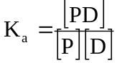 | (4.12)
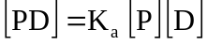 | (4.13)
where, [P] = concentration of free protein
[D] = concentration of free drug
[PD] = concentration of protein-drug complex
Ka = association rate constant
Kd = dissociation rate constant
Ka > Kd indicates forward reaction i.e. protein-drug binding is favoured. If PT is the total concentration of protein present, bound and unbound, then:
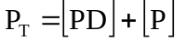 | (4.14)
If r is the number of moles of drug bound to total moles of protein, then,
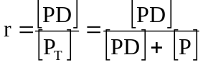 | (4.15)
Substituting the value of [PD] from equation 4.13 in equation 4.15 we get:
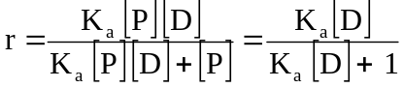 | (4.16)
Equation 4.16 holds when there is only one binding site on the protein and the protein-drug complex is a 1:1 complex. If more than one or N number of binding sites are available per mole of the protein then:
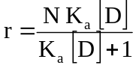 | (4.17)
The value of association constant, Ka and the number of binding sites N can be obtained by plotting equation 4.17 in four different ways as shown below (see Fig. 4.4.).

  - Direct Plot is made by plotting r versus [D] as shown in Fig. 4.4a. Note that when all the binding sites are occupied by the drug, the protein is saturated and plateau is reached. At the plateau, r = N. When r = N/2, [D] = 1/Ka.
  - Scatchard Plot is made by transforming equation 4.17 into a linear form. Thus,
(4.17)
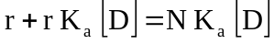
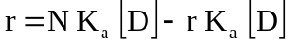
Therefore,
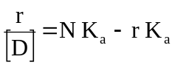 | (4.18)
A plot of r/[D] versus r yields a straight line (Fig. 4.4b). Slope of the line = – Ka, y-intercept = NKa and x-intercept = N.

  - Klotz Plot/Lineweaver-Burke Plot (Double Reciprocal Plot): The reciprocal of equation 4.17 yields:
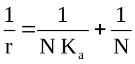 | (4.19)

A plot of 1/r versus 1/[D] yields a straight line with slope 1/NKa and y-intercept 1/N (Fig. 4.4c).

  - Hitchcock Plot is made by rewriting equation 4.19 as –
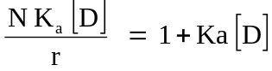 | (4.20)
Dividing both sides by NKa gives –
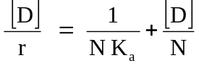 | (4.21)
Equation 4.21 is Hitchcock equation according to which a plot of [D]/r versus [D] yields a straight line with slope 1/N and y-intercept 1/ NKa (see Fig. 4.4d).

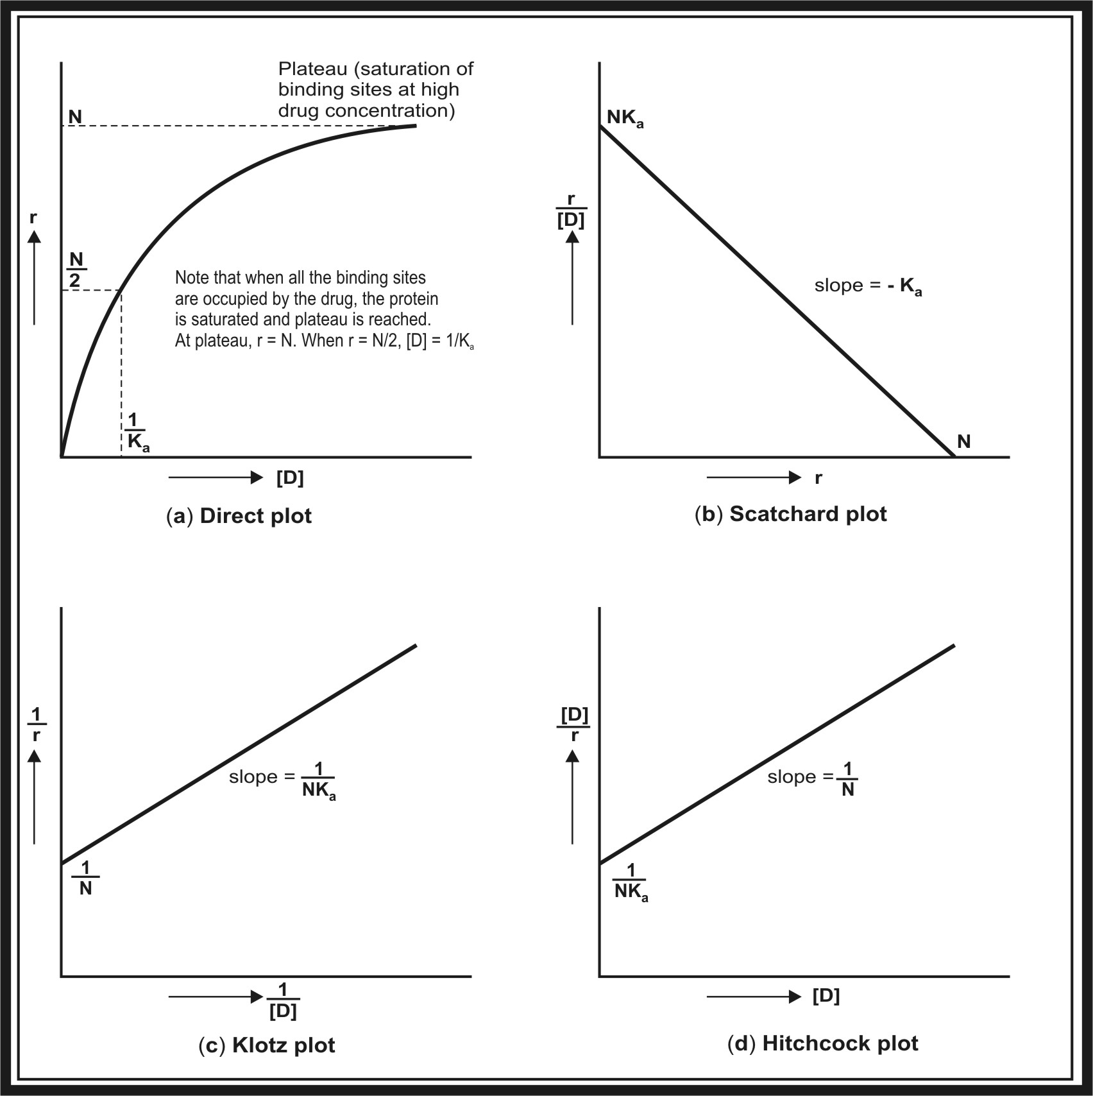
Fig. 4.4. Plots used for the study of protein-drug binding. (a) Direct plot; (b) Scatchard plot; (c) Klotz plot; and (d) Hitchcock plot.

QUESTIONS
- A protein bound drug is both pharmacokinetically as well as pharmacodynamically inert. Explain.
- When is drug binding considered irreversible? What could be the consequence of such an interaction?
- Classify the body components to which drugs normally bind.
- Why does binding of a drug to plasma proteins occur to a large extent in comparison to binding to other tissue components?
- Why is HSA considered a versatile protein for drug binding?
- With examples, name the various drug binding sites on HSA.
- Binding of drugs to erythrocytes could be as significant as binding to HSA. Explain.
- From distribution viewpoint, what is the significance of tissue-drug binding?
- Though imipramine and chlorpromazine are more lipophilic than thiopental, they do not localize in fats. Why?
- List the factors influencing protein binding of drugs.
- Define displacement interaction. What characteristics of the displacer and the displaced drug are important for displacement interactions to be clinically significant?
- Displacement of a drug with a large Vd from its plasma protein-binding site may not produce significant toxic reactions. Why?
- How do the acidic drugs such as sulphonamides/NSAIDs precipitate kernicterus in neonates?
- What is the influence of protein binding and displacement interaction on the elimination half-life of a drug?
- Give two reasons for administering large digitalizing dose of digoxin to infants suffering from CCF?
- What is the influence of various disease states on plasma protein level and drug binding?
- How would the plasma protein-drug binding influence sink conditions and absorption of a drug from the GIT?
- Renal excretion of penicillins is unaffected by protein-drug binding. Why?
- Give examples where binding of an agent to a specific tissue can be used for diagnostic purpose.
- How can the principle of binding be used for drug targeting?
- Derive the relationship showing that greater the free concentration of drug in plasma, larger its Vd.
- Warfarin has a Vd of 8 litres in a 70 Kg man and is 90% bound to plasma proteins. Given that the plasma volume is 3 litres and tissue volume 39 litres, determine -
a. The fraction of drug unbound to tissues.
Answer: 0.78.
b. The % increase in free plasma drug concentration if 10% of bound warfarin is displaced by phenylbutazone.
Answer: 90%.
c. The new Vd after the displacement assuming that the tissue binding is unaffected.
Answer: 12.5 liters.
d. From the answer of question (a), suggest whether the displacement will be clinically significant or not.
- For a drug showing protein binding, the two points on the Scatchard plot of r versus r/[D] are: (0.6, 1.2 x 104) and (1.2, 0.9 x 104).
a. Determine the association constant.
Answer: Ka = 0.5 x 104.
b. How many binding sites are present on the protein molecule?
Answer: N = 3.
c. If the points of Scatchard plot are transformed onto the Lineweaver-Burke plot (1/r versus 1/[D]), what will be the slope of the line?
Answer: Slope = 1/NKa = 0.67 x 10-4.
d. Compute the x-axis intercept of Lineweaver-Burke plot.
Answer: 1/N = 0.33.
e. Are the values of Ka and N computed from both the plots same?

